**Aim : Matrix Multiplication using MapReduce.**

Step 1 : Open terminal > Create two text files of matrix m1.txt and m2.txt.

[cloudera@quickstart ~]$ cd ~/Desktop

[cloudera@quickstart Desktop]$ mkdir matrix_mul

[cloudera@quickstart Desktop]$ cd matrix_mul

[cloudera@quickstart matrix_mul]$ gedit m1.txt

m1

**1 2 3**

**4 5 6**

[cloudera@quickstart matrix_mul]$ gedit m2.txt

m2

**4 5 6**

**7 8 9**

**1 2 6**

Step 2 : Create Mapper file mapper.py

[cloudera@quickstart matrix_mul]$ gedit mapper.py

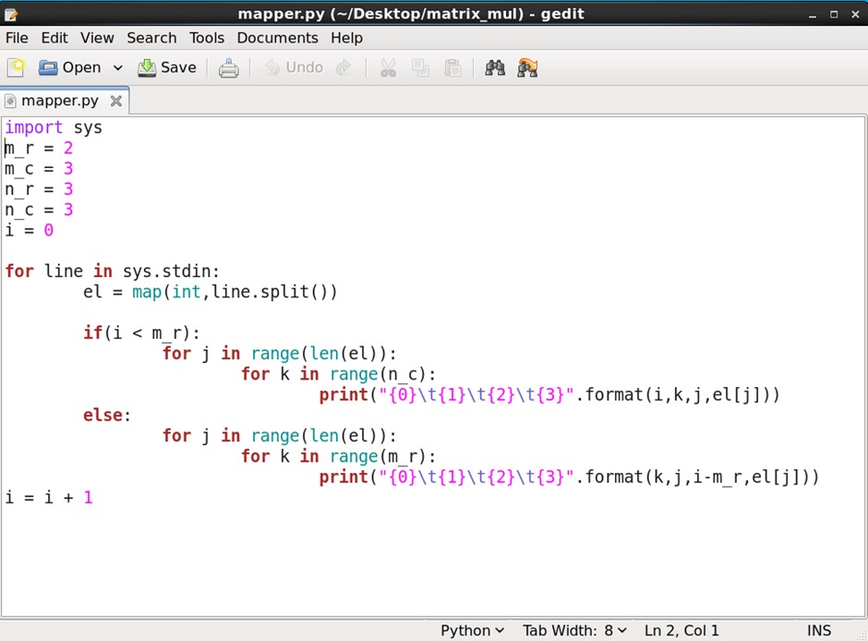

[cloudera@quickstart matrix_mul]$ cat m1.txt m2.txt | python **mapper.py Mapper Output :**

0 0 0 1

0 1 0 1

0 2 0 1

0 0 1 2

0 1 1 2

0 2 1 2

0 0 2 3

0 1 2 3

0 2 2 3

0 0 0 4

0 1 0 4

0 2 0 4

0 0 1 5

0 1 1 5

0 2 1 5

0 0 2 6

0 1 2 6

0 2 2 6

0 0 0 4

0 1 0 4

0 2 0 4

0 0 1 5

0 1 1 5

0 2 1 5

0 0 2 6

0 1 2 6

0 2 2 6

0 0 0 7

0 1 0 7

0 2 0 7

0 0 1 8

0 1 1 8

0 2 1 8

0 0 2 9

0 1 2 9

0 2 2 9

0 0 0 1

0 1 0 1

0 2 0 1

0 0 1 2

0 1 1 2

0 2 1 2

0 0 2 6

0 1 2 6

0 2 2 6

Step 3 : Create Reducer file reducer.py

[cloudera@quickstart matrix_mul]$ gedit reducer.py

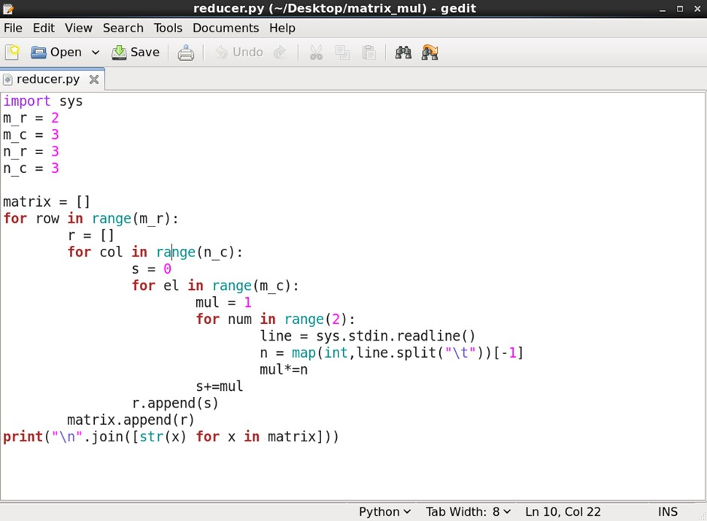

Step 4 : to get matrix multiplication :

[cloudera@quickstart matrix_mul]$ cat m1.txt m2.txt | python mapper.py | python reducer.py

**Output :**

**[7, 37, 91]**

**[61, 127, 217]**